**PF-LAB**

*SYED MUHAMMAD MEHDI RAZA*

*24K-0931 .*

**FLOWCHART**

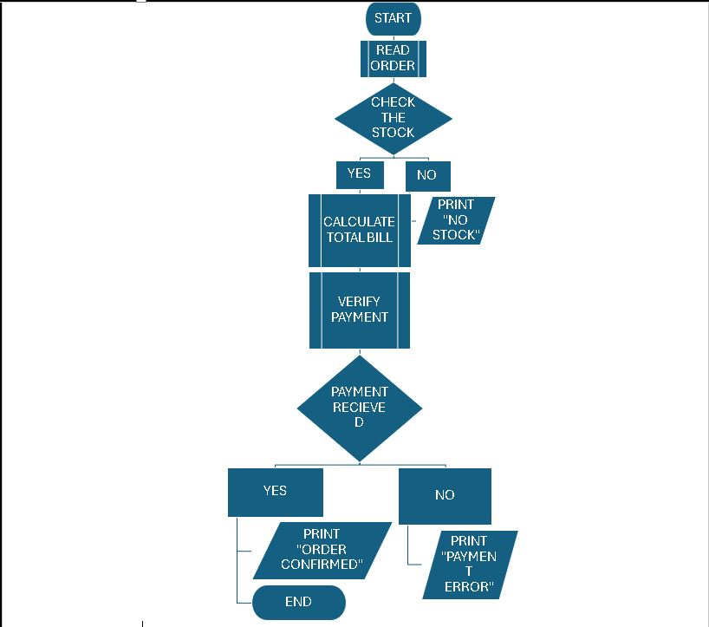

***PSEUDOCODE***

1. ***Find if the number is multiple of 5.***

START

//INPUT/OUTPUT

INPUT NUMBER “N”

//VARIABLES AND INITIALIZATION

SET ANSWER TO 0

//PROCESS STEPS

SET ANSWER= N/5

//CONDITIONAL STATEMENTS

IF ANSWER IS INTEGER

PRINT “NUMBER IS MULTIPLE OF 5”

ELSE

PRINT “NUMBER IS NOT A INTEGER OF 5”

END

1. ***Check if a character is uppercase or lowercase.***

START

//INPUT/OUTPUT

INPUT CHARACTER

//CONDITIONAL STATEMENTS

IF CHARACTER >=’A’ AND CHARACTER<= ‘Z’

IF CHARACTER IS BETWEEN ‘A’ AND ‘Z’

PRINT ”CHARACTER IS UPPER CASE”.

ELSEIF CHARACTER>=’a’ AND CHARACTER<=’z’

IF CHARACTER IS BETWEEN ‘a’ and ‘z’

PRINT “CHARACTER IS LOWERCASE”

END

***3. Create a small calculator which only does ‘+’ or ‘*‘Operations. (Hint: Take three variable inputs***

***with one being used for the operator)***

START

//INPUT/OUTPUT

INPUT NUM1

INPUT OPERATOR

INPUT NUM2

INPUT ANSWER

//VARIABLE AND INITIALIZATION

SET ANSWER TO 0

//CONDITIONAL STATEMENTS

IF OPERATOR IS ‘+’ PERFORM ADDITION

ANSWER= NUM1+NUM2

PRINT “ANSWER”

ELSEIF OPERATOR IS ‘*’ PERFORM MULTIPLICATION

ANSWER= NUM1*NUM2

PRINT “ANSWER”

END

***4. Check whether a given number is positive, negative, or zero.***

START

//INPUT/OUTPUT

INPUT NUM

//CONDITIONAL STATEMENTS

IF NUM>0 THEN

PRINT ”NUM IS POSITIVE”

ELSEIF NUM=0

PRINT “NUM IS ZERO”

ELSEIF NUMM<0

PRINT “NUM IS NEGATIVE”

END

***5. Determine if a person is a teenager (between 13 and 19 years old).***

START

//INPUT/OUTPUT

INPUT ‘AGE’

//CONDITONAL STATEMENTS

IF ‘AGE’>= 13 AND AGE<=19

PRINT “PERSON IS TEENAGER”

ELSE

PRINT “PERSON IS NOT A TEENAGER”

END

# ***ALGORITHMS***

1. **Implement an algorithm to determine if a given year is a leap year. A leap year is divisibleby 4, but not divisible by 100, except if it is also divisible by 400.**

**STEP1**.ASK USER TO ENTER ‘YEAR’

**STEP2**.CHECK IF YEAR IS DIVISIBLE BY 4

IF MOD4=0 , PROCEED TO NEXT STEP

ELSE GO TO **STEP 6**

**STEP3**.CHECK IF YEAR IS DIVISIBLE BY 100

IF MOD100=0, PROCEED TO NEXT STEP

ELSE GO **TO STEP5**

**STEP4.**CHECK IF YEAR IS DIVISIBLE BY 400

IF MOD400=0,PROCEED TO **STEP 5**

ELSE PROCEED TO **STEP 6**

**STEP5** DISPLAY “THIS IS LEAP YEAR”

**STEP6** DISPAY “THIS IS NOT LEAP YEAR”

***Calculate the area of a circle given its radius r.***

**STEP1**: ASK USER TO ENTER ‘RADIUS’

**STEP2**: SET AREA TO (3.142*RADIUS*RADIUS)

**STEP3**: DISPLAY AREA

***Find the median of three given numbers.***

STEP1: ASK USER TO ENTER NUMBERS ‘N1’, ‘N2’, ‘N3’

STEP2: ARRANGE NUMBERS FROM SMALLEST TO LARGEST

STEP3: READ MIDDLE NUMBER ‘M’

STEP4: DISPLAY “M IS MEDIAN OF N1,N2,N3”

***GITHUB:***

